**Output**

Computing integral I using Composite Simpson’s $\frac{1}{3}$ Rule

I = $\int_{0}^{1}{\frac{\tan^{-1}{x}}{x}}$

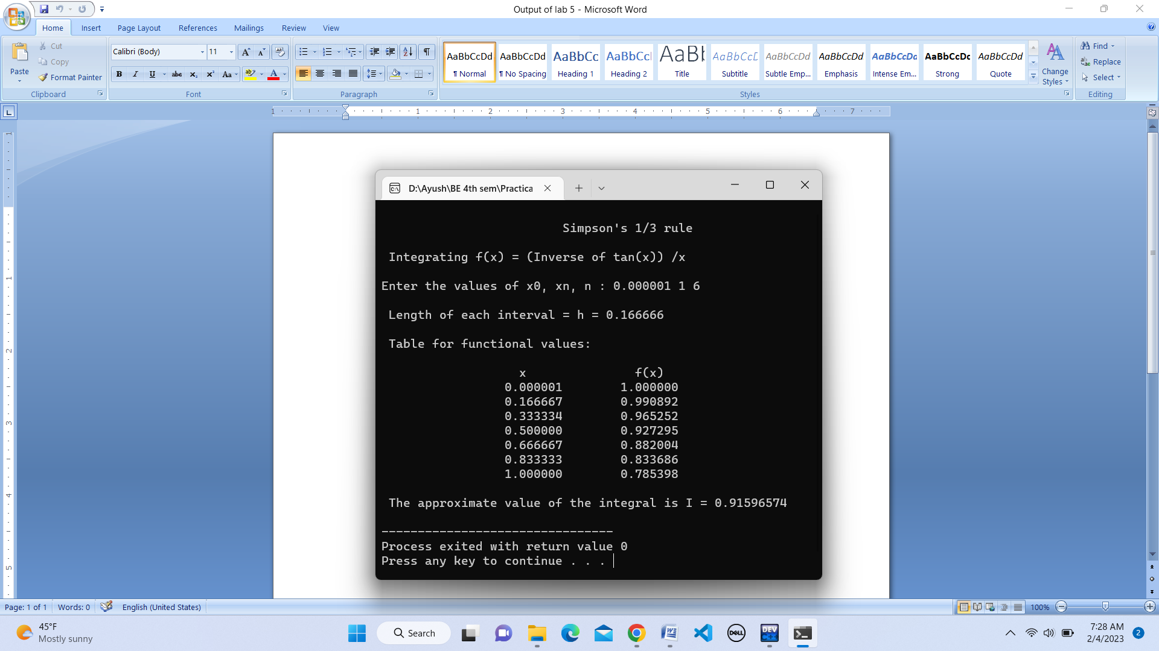

**Output**

Computing integral I using Simpson’s $\frac{3}{8}$ Rule

I = $\int_{0}^{1}{\frac{\tan^{-1}{x}}{x}}$

